Technical Writing
MCT Task 1
Mohan Chittajallu
MCT 2
4/28/2017

INTRODUCTION
The document I choose for this task is “Getting started with Logitech wireless mouse M525.” Logitech has created this technical information to help people connect to its wireless mouse.

INTENDED AUDIENCE
The intended audience for this process document is anyone using a desktops computer or laptops computer with a traditional mouse. Even though the intended audience is not mentioned in the document, we can guess the audience by the way things have been described in the document. The document assumes that the users will be able to understand the basic technical language written in the document to explain the process of using a wireless mouse.
GENRE CONVENTIONS
For this IT process the genre convention used in the document is like an instructional based format. The document is in a usable form, which makes it easy for people to read. The table of contents, diagrams, and lists of instructions easily answers the questions that the audience has which helps them to use the information in a perfect manner. This document mainly deals about how to set up a wireless mouse to a computer. It also briefly explains how to operate the mouse, its features, and troubleshooting solutions. There is also visual aid that might help the audience get through the setup process quicker and easier. In a few cases, the document deals with some technical words, such as “unifying receiver,” in the process of its explanation which is not that difficult to understand for the audience overall. (Getting started with wireless mouse M525 [PDF], (2011, February 27)).

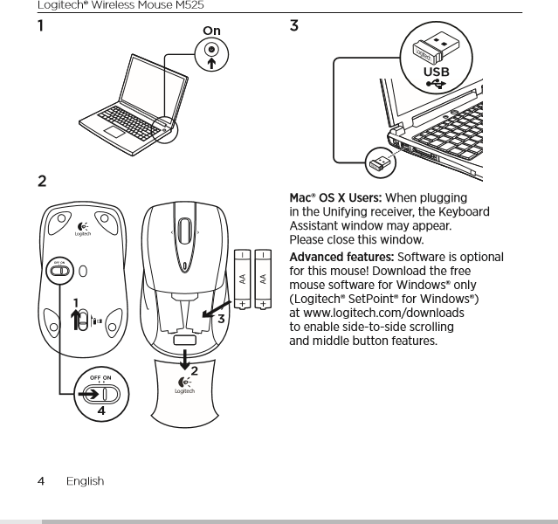
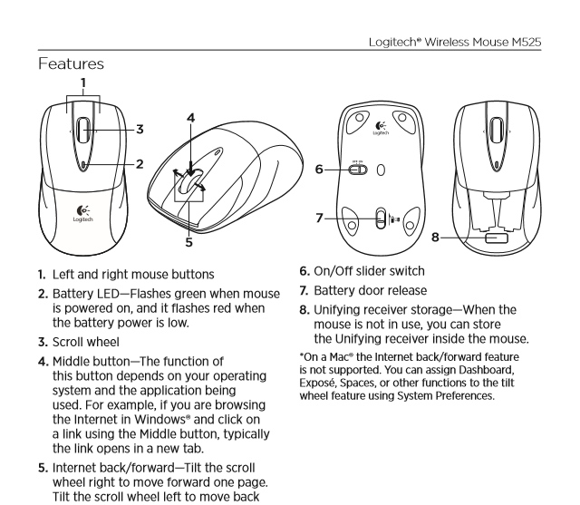
TECHNICAL PRINCIPLES
1) Grammar: there are multiple languages used in the document. But according to English the language or the grammar used is in the form that every person can understand, without complex words. The few technical terms are not difficult to understand for unfamiliar users. The grammar used in the document sentences was brief and easy to understand. (Getting started with wireless mouse M525 [PDF], (2011, February 27)).

2) Writing style: the writing style of the document uses a formal language because it addresses an audience with professional language since the document gives clear instructions on setup…. (Getting started with wireless mouse M525 [PDF], (2011, February 27)).
3) Using positive words: since the writing style of the paper had been in formal format so naturally there were no negative sentence or words in the paper. Which does not disappoint the audience while reading the document (Getting started with wireless mouse M525 [PDF], (2011, February 27)).
4) Active voice: the document is completely in active voice. Since this document deals with explain the process of how to connect wireless mouse to a computer that should be interactive. Hence, the document has been written in the active voice as per technical principles (Getting started with wireless mouse M525 [PDF], (2011, February 27)).
5) Avoiding long sentence: throughout the document, there is no long sentence used. Which, if used might make the reader bored off, which acts as a negative point. Hence, we can say that the document has passed all technical principles (Getting started with wireless mouse M525 [PDF], (2011, February 27)).
6) The punctuation used in the document is in the standard form which is required to maintain in a formal form of paper. Hence this point also satisfies technical principles (Getting started with wireless mouse M525 [PDF], (2011, February 27)).
From looking at the above description on document we can say that it is well written and effective. Now getting to part 3 of the task:
STRUCTURE
1) Structure: - In terms of every steps described in the document, the instruction is very clear and laid out in clear point. The visual aid provided in the document help the reader go through he steps easier and gives a reference point. so, explains on how to install a software in the computer if the driver isn’t present in a few cases which is really helpful to the audience who cannot the mouse to the mouse in absence of the software which this step helps them to install the software and proceed forward. So, overall the structure is good (Getting started with wireless mouse M525 [PDF], (2011, February 27)).

DESIGN ELEMENTS
2) Design elements: the design of this document, there is no too much information provided which does not make the audience bored off which is a positive point. The information has been described in multiple languages which might help the audience one or another language who doesn’t know one language which is another good point, the steps have been described in number points which gives good clarity to the audience. The font size isn’t that difficult to understand for the audience, which in a friendly format. But the color of the document used is grayscale which might not attract the audience’s mind easily (Getting started with wireless mouse M525 [PDF], (2011, February 27)).

ILLIUSTRATIVE COMPONENTS
3) Illustrative components: there are many illustrative components in the document that helps the audience to set up the wireless mouse easier. There are both major installation instruction and also good visual aid (Getting started with wireless mouse M525 [PDF], (2011, February 27)).
APPROPRIATE FOR PRINT
From the viewpoint of the document it is in friendly or understandable printable format has the reason I have said earlier the font size of the document isn’t that difficult for the audience to understand has they have used a normal or general font size. Since they have divided the document pages according to the multiple languages uses the audience can take a print of required languages and pages. Each language has 4 pages. The visual is in grayscale which might not be very bright when printed. Overall, compared to the majority points mentioned above, the document is very much printable (Getting started with wireless mouse M525[PDF], (2011, February 27)).
.
ORGANIZATION FOR ONLINE ACCESS
For the purpose of online access the document is organized in a way which makes the audience to understand easily with no confusion and maintains the same throughout the document. It’s very much readable and easily accessible on the website. The font and the color used in the document do not make the reader feel difficult to read. And the document can easily be accessed through the google webpage or in any other webpage asking for a Logitech wireless mouse M525 setup. Since many people use pdf format in their laptop this document has been uploaded to online in pdf format which can be easily accessed with no software issues. The document is on a white background with a black font and hence it is a very readable on a laptop or on a computer. Since nowadays everything has become digital many people are connected to the internet. Therefore, getting access to the document isn’t difficult. The document has been organized in a way in which the title has been titled has per the content of the document. The audience can either read the whole document if the topic is reliable to their topic. There is also visual aid presented in the document that makes the online audience easier to read the document rather than reading the whole document line to line. The organization of the document is well organized in a manner which all the audience can understand it and since it is in digital format the document can be save n number of types and can be easily accessed by the audience (Getting started with wireless mouse M525[PDF], (2011, February 27)).
IMPROVEMENTS
From analyzing the document, there are not much improvement that needs to be made to the document. The required improvements are:
- A color visual aid might make the document more colorful and attractive to the audience, which makes the audience to set up the wireless mouse easier.
In general words, many people learn to think practically rather than theoretically. Therefore, presenting a colored visual aid document might help the audience get through it faster and more understandably. For non-technical users, colored visuals will draw their attention to specific parts of the mouse and make them easier to find in the directions. Having color in the document helps draw the audience’s attention to the helpful visual aids.
- If FAQs (Frequently asked questions) were provided in the document it might help the audience find a solution to their frequent questions.
In general words, FAQ are the frequently asked question from the audience. These questions are brought together in a list. Having a document of the most repeated questions with solutions might help the audience to find their answer quicker. This FAQs should be added at the end of the document. Therefore, when the audience goes through the paper and have any question they can go through the FAQs provided at the end might help answering.
CONCLUSION
Finally, by concluding it can be said that the document is very well written. It has all the information needed to set up the mouse in a very good understanding way which in any manner it does not confuse the reader. The author of the document has used, effective abbreviations, terms in the document, etc..., and in terms of the design, the document is satisfactory. In terms if illustrative components if the visual aid have been in color format it would be much better (Getting started with wireless mouse M525 [PDF], (2011, February 27)).

References
Getting Started with Wireless Mouse M525 (2011, February 27). Retrieved from https://www.logitech.com/assets/42322/2/m525-quick-start-guide.pdf

